**Questions**

1. What is the smallest memory object that can represent a character of information?
   1. Think… How many upper case letters in the alphabet (A to Z)?

* 26
  1. Think… How many lower case letters in the alphabet (a to z)?
* 26
  1. Think… How many number digits (0 to 9)?
* 10
  1. Think… How many punctuation marks?
* 14+More
  1. Add them all up
* 130

1. Research the ASCII characters set. What is it and how is it related to computer memory?

* The ASCII character set is a set of computer data that uses numeric codes that range from 0 – 27. The most used method is the American Standard code for information Interchange or also known as ASCII. It is the crucial method used to communicate between computers using the binary system and how it was set up. With each letter or character representing 1 byte or 8 bits.

1. How are strings of characters (Google “String”) represented in computer memory?

* Strings are stored as hex codes which once the computer reads convert into text. The hex codes are how the computer reads the text and how it stores the text, but humans read the test as text. Meaning to put it simply, the computer stores “string” as (53 74 73 69 6E 67)

1. How are negative integers represented in computer memory? (Include a diagram)

* Negative integers are stored in what is called 2’s complement. The other major way of storing negative signed numbers is called one’s complement. Since the binary values increase by 1, it could be represented form left to right or from right to left.  
  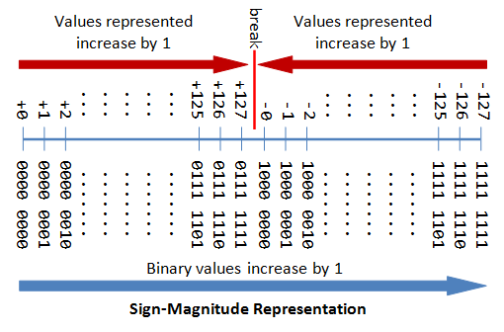

1. How are decimal numbers (Google “Floating Point”) represented in computer memory? (Include a diagram)

* In Memory, a floating point number is represented similarly. One bit has the sign, some bits form the factor as a fixed precision number (“mantissa”), the remaining bits form the exponent. Significant differences to base-10 engineering notation is that of course now the exponent has base-2. The exact size of each part depends on the exact floating-point standard you are using.  
  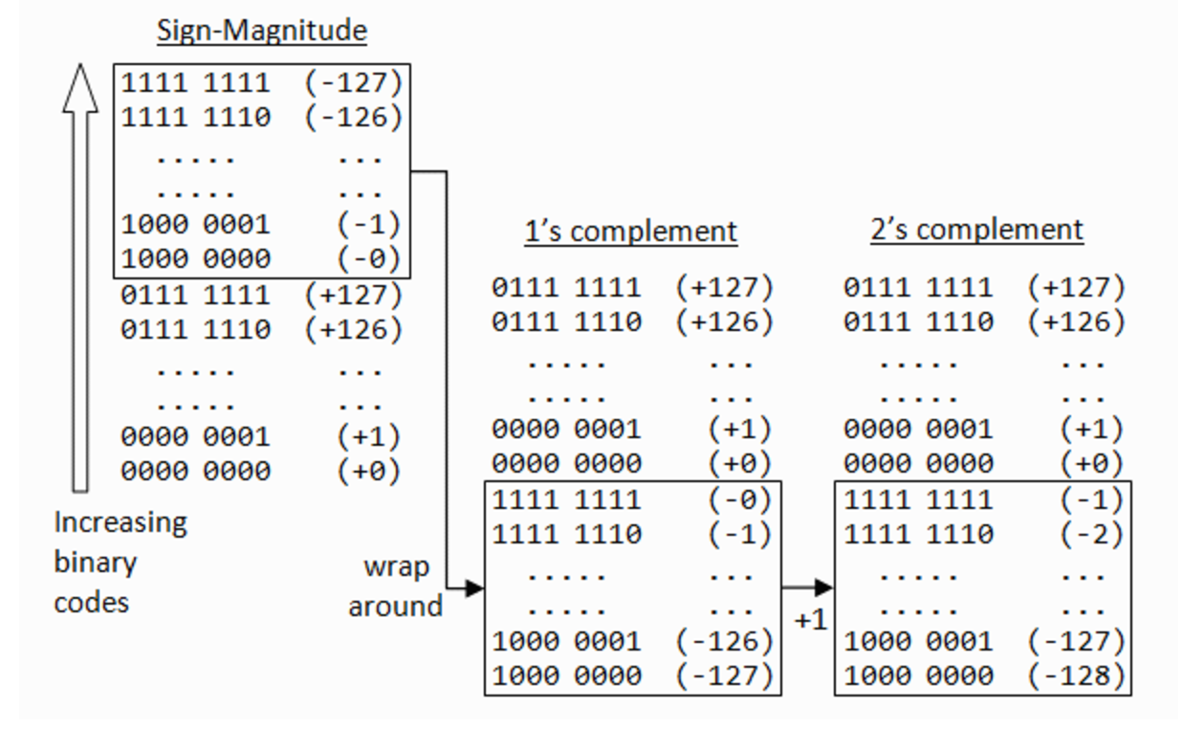

1. A Pixel is computer memory structure used to store image information. How is a Pixel represented in memory? (Include a diagram).

* Pixels are the smallest individual element in an image, holding different values that represents the brightness of a random color at any point. But usually, the pixels are stored in computer memory as a faster image or a map, a 2- dimensional array of small integers.

